

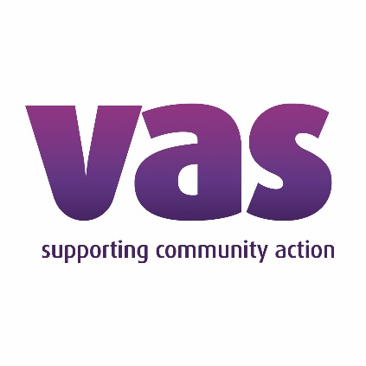


Information for Applicants: Suicide Prevention Champions Programme

Contents:
- Project Background
  - What will I get?
  - What do you need from me?
  - How will you be deciding?
- Application Questions
- Signatures
- Project Team Details
Please read all the information in this document carefully before completing and returning your application form.

Project Background
The Mental Health Partnership Network (MHPN), Sheffield Autism Partnership Network (SAPN), Sheffield City Council (SCC) and Voluntary Action Sheffield (VAS) are working together to deliver a new pilot project for Suicide Prevention training and staff support.
This joint approach has allowed SCC to move funding for suicide prevention initiatives to the voluntary sector (via VAS), while the MHPN and SAPN work together to make sure that funding is meeting the needs and priorities of our VCSE partners.
After consultation with individuals and VCSE organisations, it was found that the biggest need for the sector was access to appropriate and in-depth training around suicide prevention, especially for current high-risk groups: children and young people (CYP), and Autistic people. We worked with individuals and organisations to develop a pilot programme whereby organisations can nominate a member of staff to attend free Suicide Prevention training and be part of an ongoing support network.

What will I get?
As part of this cohort, you’ll be given fully-funded training on suicide prevention and awareness for both Autistic people and children and young people, delivered by Autism Oxford and PAPYRUS. By completing both training courses, you will become a Suicide Prevention Champion for your organisation, with the ability to better address suicidal thoughts, feelings and intentions with people who come to your organisation for support.
You’ll also be part of a network of people working in similar roles who have also taken these training packages, facilitated by a mental health professional, to give you space to talk about your experiences with implementing the training into your work and work through any challenges. This is particularly important to help mitigate any vicarious trauma or mental health impacts that this work has on you, to ensure your safety and wellbeing.

What do you need from me?
It’s crucial that you attend both training courses, which will take place in person over 2 half-day sessions on 19th June and 2nd July 2025, as well as a half-day online session in the first week of September (date TBA). If you don’t, your organisation may be asked to cover the cost of the training – we will confirm the final dates and times with you before you’re asked to sign any grant agreements to this effect, but please be sure that the dates advised are suitable before applying where possible. You won’t be able to send another member of your organisation on your behalf or attend virtually. If you need reasonable adjustments implemented to allow you to partake in the training, please get in touch with the project team (details can be found at the end of this document) before applying, where we can discuss the best way to make this work.
You will also be expected to attend regular network meetings for the 6 months following the training sessions - we anticipate these will be one hour a month on a video call, but the format will be co-created between the facilitator and the cohort so they may be longer, in-person and/or more regular – if that is what works best for the group – so please be aware of this before committing. Again, if there are accessibility concerns around this then please get in touch so we can talk this through before you apply.
At the end of the year, we will be holding a learning event to close out the pilot project and help us understand how the project went and what lessons can be taken forward. You will be required to attend, and other members of your organisation will be invited as well if they would like to be involved.

How will you be deciding?
The nature of the Suicide Prevention Champion role means it is best suited to front-line workers, ideally those who are already working on wellbeing or mental health support activities. Whoever takes on this role will need to be readily available to speak with individuals who are experiencing crisis when they reach out to your organisation, using a variety of communication methods depending on their needs, as well as being available for the regular network meetings.
It is unfortunately not likely to be suited to people who regularly work remotely (if your organisation does not have a physical presence, please get in touch before applying), who’s jobs do not bring them into contact with the public and/or who work less than 3 days per week in one organisation.
As this is a pilot project, we only have 30 spaces available. We will be prioritising organisations who work with Autistic people and/or children and young people in the first instance, followed by other national strategy priority groups balanced with local need. If your organisation does not fall within these priority areas, this does not automatically exclude you! We welcome all applications and will consider every applicant carefully.

Application Questions
Applicant Name: _____________________________________________________________
Applicant Job Title: ___________________________________________________________
Overview of applicant main role responsibilities and tasks:
Please use this space to talk about your day-to-day activities, particularly in relation to the outline above of who is best suited for this programme.

Please confirm you agree with the following:
I will be available on the training dates detailed above □
I can commit to the regular network meetings □
If I fail to attend all of the training, my organisation may be liable for the cost □

Signatures
Applicant |  | Date
Organisational Lead |  | Date

Project Team Details
- Katie Drinkwater
Autism Partnership Lead at Voluntary Action Sheffield and Sheffield Autism Partnership Network Chair
k.drinkwater@vas.org.uk
- Rebecca Lawson
Mental Health Partnership Network Strategic Co-ordinator
rebecca.lawson@sheffieldmind.co.uk
- Joanna Rutter
Health Improvement Principal
Director of Public Health Office

